Restaurant Reservation Consumer / Restaurant Reservation Producer Service Implementation

1. Manifest implementation

Restaurant Reservation Consumer Manifest file

Restaurant Reservation Producer Manifest file

1. All commands of bundle install and run in OSGi framework.

2: Restaurant Reservation Consumer

3: Restaurant Reservation Producer

1. Behaviours & Outputs
   1. Admin [Manager]

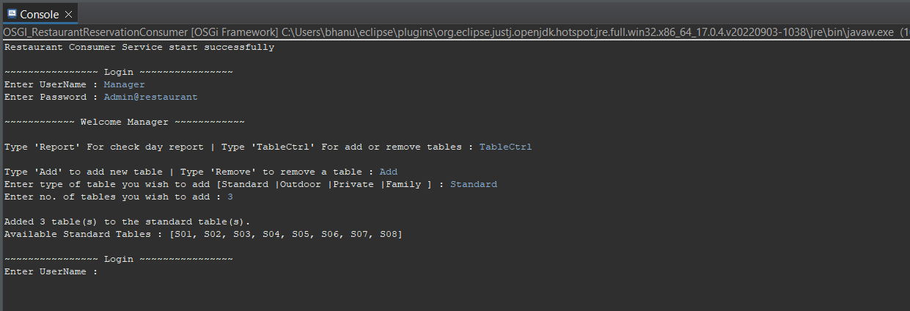As an administrator/ Manager, can add table to the selected table type.

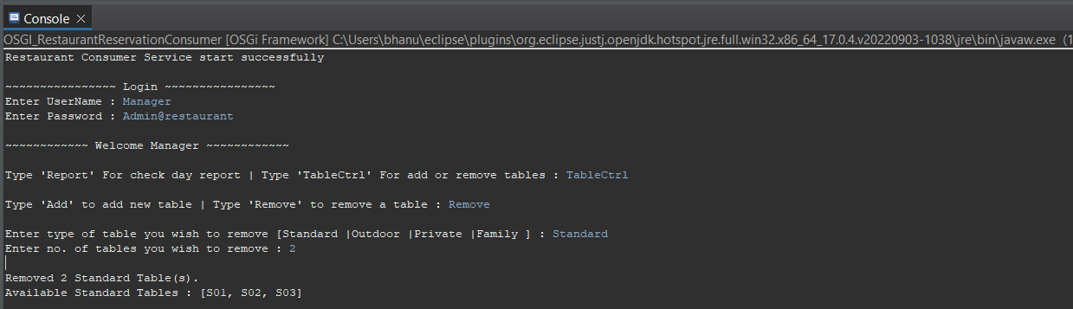As an administrator/ Manager, can remove table from selected table type.

As an administrator/ Manager, can view day report which include reserved tables and total income at the moment.

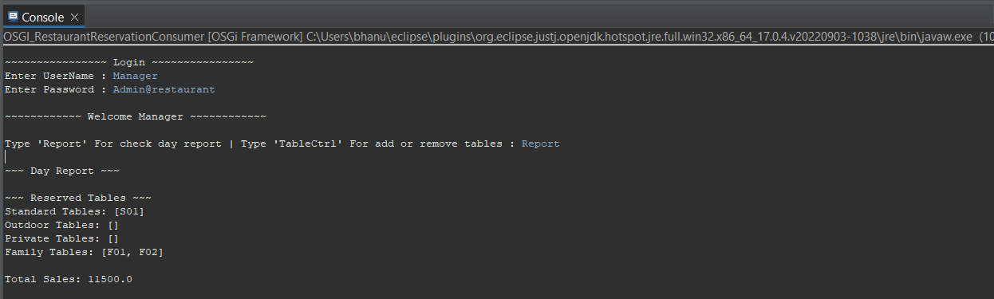

* 1. Reservation Agent

As an Reservation Agent, can make a reservation to the client.

As an Reservation Agent, can cancel any reservation.